My Work Habits – Primary – Individual
Assignment

I am someone who…

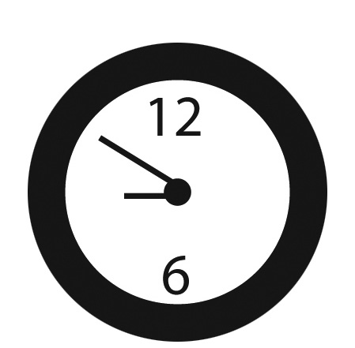

Can tell an adult when something is not safe (e.g., glass on the ground, water on the floor).
Cheers for my teammates and shows good sportsmanship.
Comes to school every day and on time.

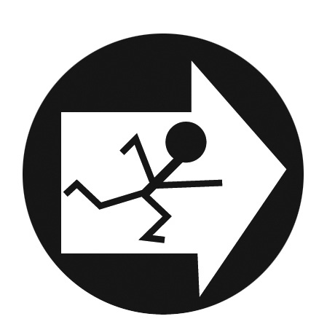

Puts books, pencils and art materials back in the right spot.
Can complete puzzles, crafts and games on my own.
Loves to help my friends when they need it.

Asks for help when I need it. Can greet a new student or
class visitor with a smile.
Can run a lemonade stand to make money for a charity.

